

**PUSL2021 Computing Group Project.**

**Project Proposal.**

**Pet Care Mobile Application.**

[Group-17]

|  |  |
| --- | --- |
| **Student name** | **Student ID** |
| Sammu Silva | 10898913 |
| Jayaweera Jayaweera | 10898507 |
| Iddamalgoda Bandara | 10898739 |
| Egoda Hettiarachchi | 10898774 |
| Galagedra Senevirathne | 10898908 |

**Table of Contents**

**Project Overview & Introduction.** 3

**Objectives Of The Project.** 4

**Target Users.** 6

**I.** **To whom this important?** 6

**II.** **Why this is important to target users?** 6

**III.** **Use case diagram.** 6

**Application Features & Description.** 7

**Requirements.** 8

**I.** **Technologies adopted for implementation** 8

**Time Frame.** 10

**Gantt Chart** 10

**Future Implementation.** 11

**Appendix** 11

**Flow chart** 11

**References** 13

# **Project Overview & Introduction.**

Through our app, we will prepare this software for you to set a daily goal to systematically eat your pets, manage food, and know the necessary information about their health. We provide all this information to you using artificial intelligence.

For this, we will give the right amount of food to your pet according to its height, weight, and age.

In addition to our tracking, you can also monitor your pet's weight gain and loss, and diet monitoring will help you gain a better understanding of your pet's fitness and health.

Establish the suggested daily food consumption limit, determine the amount of food to be given in each meal, and keep track of how frequently your pet eats. You'll get a notification on your phone 15 minutes before the feeding time to remind you; simply set the feeding time and the window for when you want to get that reminder.

Apart from that, the healthcare feature we have used here has also added the facility of showing your pet to a vet whenever you need it.

To use the mobile application that we created for this, the user must first be registered there.

That is, we have decided to collect username, password, email, or phone number as registration details.

First Stage Once the user has successfully registered, he will have a separate profile. Once registered, he can easily login to the system using his username and password.

After logging in, he can monitor the dashboard, enter the details of his sick pet, and get the information the user needs through artificial intelligence.

This mobile software will undoubtedly be very useful for users who frequently check their pet's health. You can create a separate profile for your pet and get all the information in one place, so you will be able to spend time with your pet without any worries.

# **Objectives Of The Project.**

1. **The motive behind this project is to have one platform to connect all who take care and have their pets.**

* With this pet owners , veterinary clinics and pet-related services providers get in one platform.

1. **Providing an application that pet lovers can put their pets’ life details to get a helping hand that can take care of them quickly.**
2. **Providing a fastest way to find correct solutions with minimum time.**

* The fastest way to find correct solution is always being lean and approaching a solution with minimum time spent.

1. **Ability to manually add health entries and make the electronic health records which are comprehensive and usable.**
2. **Ability to keep track of medical records.**

* This have and ability to remind about upcoming treatments with entire medical history of pets and user can access to their medical history anytime.

1. **Providing an AI bot that makes leaps and bounds in medical care for both dogs and** **cats.**

* These advanced bots can also answer pet health questions, analyze symptoms and provide medical information all on their own. And also if a doctor is needed, the bot will determine and offer a direct connect with them.

1. **Veterinary telehealth.**

* With comprehensive health data the user will able to get an alert when doctors are available and what conditions user should channel for. This app connect the user directly to veterinarian as needed either through the app or directly through your mobile phone through a call.

1. **Notifying the user regarding pet’s food consumption and water consumption.**

* With comprehensive feeding data, the user will get an alert when the pet needed to be feed and what meals/diet should give.

1. **Providing and AI bot that monitor vital signs, eating and drinking behavior and notify anything unusual that needs to be addressed.**
2. **Providing confidentiality to pet data.**

* Due to presence of a user login, all the information is given to the user only. So the confidentiality of the pet’s information is protected.

1. **Providing pet owners an efficient, convenient and low-cost tool for pet care.**

# **Target Users.**

## **To whom this important?**

This is important for pet owners with busy life style and also this gives and side support for doctor.

## **Why this is important to target users?**

Pets need special treatment and difficult than it ever was because of hectic lifestyle of pet owners nowadays. So this will be helpful to guide the owners with pet parenting as pet parenting is not easy. This will be rounded up to pet health care advices from pet feeding schedules. So this app will make life that little easier. And this app will helps to the strugglers who are struggling with remembering various appointment. So the users only have to create a profile and this will give reminders for vaccinations, vet appointment and other custom reminders on time.

## **Use case diagram.**

# **Application Features & Description.**

1. **User registration**

To use this application, it is mandatory to register the user into the app. The user can easily register by entering their details.

1. **User login**

The pet owner which uses the app can login by entering his/her username and passwords

1. **User profile**

This contains pet owners’ information including name, number of pets, pet name…. Etc.

1. **Pet profile**

This contains the information needed to be include in the pet profile. This contain 3 options as health, feeding , quick actions .

* Health option

This contains vet visits, details about vaccinations, medicines and vitamins. And also this contain BMI calculator and solutions for health conditions such a obesity and malnutrition.

Ex: recommended exercises.

* Feeding option

This contains pet diet plans, food consumption and water consumption

* Quick access

This contain two options

1. Appointments - This contains quick channeling (online)
2. Reminders - This contains reminders for vaccination, feeding and medications.
3. **Calendar**

This contains appointments such as online appointments and visits, activities, vaccines and general reminders.

1. **Notifications**

This contains reminders, app new updates and search functions.

# **Requirements.**

## **Technologies adopted for implementation**

* **Programming languages**

1. **Java**

* Since this is a mobile application we decide to use the java for this project. Java is a flexible, strong programming language that enables programmers to design reliable, high-performing programmes. This can operate on any platform, including iOS and Android, because it is platform-independent. Java has many advantages for mobile applications, including security, robustness, built-in tools for mobile development, and community support.

1. **Kotlin**

* Kotlin is a modern trending programming language. It is easy to learn and this is compatible with java. It is used to develop android apps, server side apps and much more.

1. **Dart**

* An open-source and object oriented programming language that is use to develop app for ios and android.

1. **Python**

* This is a general purpose, versatile and powerful programming language.

1. **MATLAB**

* This is a high-performance language. It is develop by math works. It started out as a matrix programming language.
* **Open source frame works**

1. Flutter

* Flutter is an open source framework developed and supported by google. Flutter is a cross-platform toolkit, that can be use to develop an app on ios and android with a single codebase. Flutters use reactive programming languages such as dart.
* **Development tools**

1. Visual studio
2. Android studio

# **Time Frame.**

## **Gantt Chart**

|  |  |  |  |  |
| --- | --- | --- | --- | --- |
| **Task**  **No :-** | **Task** | **Start** | **End** | **Days** |
| 1 | Problem Analysis | 2023/08/07 | 2023/08/15 | 8 |
| 2 | Finding solution | 2023/08/15 | 2023/08/23 | 8 |
| 3 | Gathering information | 2023/08/23 | 2023/09/04 | 12 |
| 4 | Gathering software requirements and gathering requirements | 2023/09/04 | 2023/09/15 | 11 |
| 5 | Planning | 2023/09/15 | 2023/09/26 | 11 |
| 6 | Analysis | 2023/09/26 | 2023/10/04 | 8 |
| 7 | Project proposal creating | 2023/10/04 | 2023/10/20 | 16 |
| 8 | Design UI and UX | 2023/10/20 | 2023/10/30 | 10 |
| 9 | Coding | 2023/10/30 | 2023/11/10 | 11 |
| 10 | Selecting data set | 2023/11/10 | 2023/11/24 | 14 |
| 11 | Training data set | 2023/11/24 | 2023/12/05 | 11 |
| 12 | Model Training | 2023/12/05 | 2023/12/21 | 16 |
| 13 | Developing database | 2023/12/21 | 2024/01/01 | 11 |
| 14 | Developing mobile Application | 2024/01/01 | 2024/01/19 | 18 |
| 15 | implementation | 2024/01/19 | 2024/01/30 | 11 |
| 16 | System Testing | 2024/01/30 | 2024/02/16 | 17 |
| 17 | Configuration of Errors Encountered | 2024/02/16 | 2024/02/27 | 11 |
| 18 | Maintains of System | 2024/02/27 | 2024/03/15 | 17 |

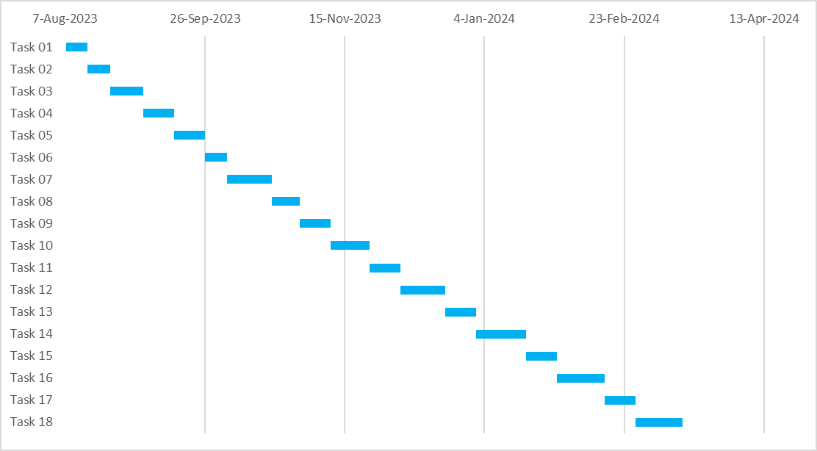

# **Future Implementation.**

Today, with the technologicalization of the world, most of the systems are driven by artificial intelligence. Based on this reason, this app is made for busy people who care for their pets very much in today's world, and there is no doubt that they can get a profitable service in a minimum amount of time. Therefore, the system we are currently making to facilitate it In the future, we hope to develop this app into a smart IoT device. Also, we hope to upgrade it to a device with a multi-angle for users to control manual feeding, exercises, disease detection, and a light speaker to hear the owner's voice.

# **Appendix**

## **Flow chart**

# **References**

DuePet. (n.d.). *Pet Food Tracker*. [online] Available at: <https://www.duepet.com/features/trackers/food/>.

Zenva (2023). How To Use Generative AI In Python - Best Courses And Tutorials - GameDev Academy. [online] GameDev Academy. Available at: https://gamedevacademy.org/how-to-use-generative-ai-in-python-best-courses-and-tutorials/ [Accessed 18 Oct. 2023].

flutter.dev. (n.d.). Learn. [online] Available at: https://flutter.dev/learn?gclid=Cj0KCQjwhL6pBhDjARIsAGx8D58NJtwYQDnrisbeEWdgFwAmK3xPWQ7uE2HlKykuDegNOf_B741tY20aAn54EALw_wcB&gclsrc=aw.ds [Accessed 18 Oct. 2023].

‌

‌

‌